Running head: ONLINE UNIVERSITY INFORMATION SYSTEM

Sun University’s Online Information System
-Link Information Solution
Darryl Bickauskas, Ryan Bockelkamp,
Matt Evans, Matt Showers
The Pennsylvania State University

Abstract

The Internet has proven to be an effective tool for obtaining valuable, real time information. Research has also shown that more and more people are using the internet then ever before. With this research in mind, an investigation was commenced into the feasibility of an online University Information System. This document will describe all processes involved in the development and implementation of that information system.

Table of Contents

0.0 Abstract 2
1.0 Problem Definition 6
2.0 About AdvanceTech 7
3.0 Software Engineering Paradigm 8
4.0 Project Planning Methodology 12
4.1 Project Scope 12
4.2 Software Functions 13
4.3 Performance Issues 14
4.4 Constraints 14
4.5 Project Schedule 15
5.0 Feasibility Analysis 18
5.1 Economic Feasibility 18
5.1.1 Total Cost of Ownership 19
5.1.2 Return on Investment 20
5.1.3 Short Term 20
5.1.4 Long Term 20
5.1.5 Intangible Cost/Benefit 20
5.2 Technical Feasibility 21
5.2.1 Hardware 21
5.2.1.1 Computers 21
5.2.1.2 Network 21
5.2.2 Software 22
5.2.2.1 “Out of Box” 22
5.2.2.2 Custom 22
5.2.3 Expertise 22
5.2.3.1 System Development 23
5.2.3.2 System Maintenance, Use, and Administration 23
5.3 Legal Feasibility 23
5.3.1 Regulations and Contracts 24
5.3.2 Privacy Responsibilities 24
5.4 Additions and Modifications 24
5.5 Conclusion 25
6.0 Estimate - Hardware requirements 26
6.1 Software requirements 27
6.1.1 Software Budget 27
7.0 Capability Maturity Model Overview 31
7.1 The Five Levels of the Software Process 32
7.1.2 Level 1 – The Initial Level 33
7.1.3 Level 2 – The Repeatable Level 33
7.1.4 Level 3 – The Defined Level 37
7.1.5 Level 4 – The Managed Level 41
7.1.6 Level 5 – The optimizing Level 43
7.2 The Development Process for E-Link 45
7.2.1 Requirements Management 45
7.2.2 Software Project Planning 46
7.2.3 Software Project tracking and Oversight 46
7.2.4 Software Subcontract Management 46
7.2.5 Software Quality Assurance 47
7.2.6 Software Configuration Management 47
8.0 Risk Management 48
8.1 Risk Evaluation Process 48
8.2 Prioritization Assignment 51
8.3 Baseline Risk Evaluation 52
8.3.1 Business Impact 52
8.3.2 Customer Related 53
8.3.3 Process 53
8.3.4 Technology Risk 54
8.3.5 Human Resources 54
8.4 Risk Matrix 55
8.5 Prioritized Risk Responsibilities 56
8.6 Options 57
9.0 Software Quality Assurance 58
9.1 Introduction 58
9.2 SQA Tasks 59
9.3 Reviews and Audits 60
9.3.1 Conducting a Review 60
9.3.2 Roles and Responsibilities 60
9.3.3 Review work products 60
9.3.4 Formal Technical Reviews 61
9.3.4 SQA Audits 61
9.4 Problem Reporting and Corrective Action/Follow-up 61
9.5 Reporting mechanisms 61
9.6 Responsibilitie 61
9.7 Data collection and evaluation 62
9.10 Software Process Improvement Activities (SPI) 62
9.11 Goal and objectives of SPI 62
9.12 SPI tasks and responsibilities 62
20.0 References 71

Table of Figures

Figure 2.0 – Team Assignments 7
Figure 3.0 The Waterfall Model 11
Figure3.1 The Prototyping Model 11
Figure 4.5 - Gantt Chart 16
Figure 4.6 - Network Diagram 17
Figure 4.7 - E-Link Resource Tracker 17
Figure 6.0 – Budget Summary 30
Figure 7.1 - The Capability Maturity Model 32
Figure 7.1.2 – The Initial Level 33
Figure 7.1.3 – The Repeatable Level 33
Figure 7.1.4 – The Defined Level 37
Figure 7.1.5 – The Managed Level 41
Figure 7.1.6 – The Optimizing Level 43
Figure 8.1 – Risk Management Process 49
Table 8.2.1- Risk Impact 51
Table 8.2.2 - Risk Probability 51
Table 8.2.3 - Risk Timeline 51
Table 8.3.1 - Business Impact 52
Table 8.3.2 - Customer Related Impact 53
Table 8.3.3 - Risk Process 53
Table 8.3.4 - Technology Risk 54
Table 8.3.5 - Human Resources Risk 54
Table 8.4 - Risk Matrix for Baseline Risk Vulnerability List 55
Table 8.5 - Priority Assessment 56

- Problem Definition

The development and implementation of an online University information system will require the dedicated team of AdvanceTech Enterprises to create a custom software solution. AdvanceTech will develop a web-based information system that will allow Sun University students to access their personal and academic information. This system, known as -Link, will provide students with a real-time ability to view their academic summary, register for classes, change their major, get their grades, drop a course, access financial aid information and view current events. AdvanceTech will ensure the security of the student’s personal information by authenticating a username and password before connecting to the -Link information system. Faculty and staff will also have access to the system. After login, they will have the ability to view student schedules, send messages and post current news and events. System administrators will have the ability to update and maintain the database, backup the data and update the software system.

- About AdvanceTech

AdvanceTech Enterprises is a team of four highly motivated individuals that work together to create custom software solutions for educational institutions. Each member of the team has a variety of skills that assist in the design and development of each complex software engineering solution. The team will remain in constant communication by way of e-mail, telephone and ANGEL. This will enable every member of the group to determine the progress of other group members at any given time.

Team Member Information
Darryl Bickauskas dcb205@psu.edu 570-357-2859
Ryan Bockelkamp rmb234@psu.edu 570-499-8532
Matt Evans mte120@psu.edu 570-281-5949
Matt Showers mrs330@psu.edu 570-241-6696

Name | Project Manager | Database | Maintenance Support | Research/  Development | Programmer

Darryl

Ryan

Matt E.

Matt S.

Figure 2.0 – Team Assignments

3.0 Software Engineering Paradigm

There are many different software engineering process models to follow when designing a new system. To build -Link, AdvanceTech has chosen to follow the Waterfall Model with prototyping process. This process ensures that one stage of the cycle cannot be started until the prior stage is completed and approved. With the use of prototyping, Sun University will have the ability to asses each stage of development and have a better working involvement through each stage in the process. This model will ensure a more complete system, built inline with Sun University’s requirements. To see this process modeled graphically see figure 3.0.
The initial phase of this process is the requirements gathering, which will entail a gathering of the functions and behavior of the system required by its users and operators.
The successful creation of -Link depends on the data gathered in this step. AdvanceTech will work closely with administration, faculty, staff and students from Sun to determine the exact requirements of the information system. A number of surveys will be composed by AdvanceTech and distributed to these groups. Interviews will also take place on and off of campus to determine what users would like to see in this type of system. The data received by these surveys and interviews will be carefully analyzed and a requirements document will be generated from the findings.
The requirements document should be an official statement of what is required of AdvanceTech. It should be a structured document setting out detailed descriptions of system services, written as a contract between AdvanceTech and Sun University. This section of the document will be denoted as the scope. The scope introduces the major functions of the system that are required, performance and behavioral issues, and constraints that may be occurred.
Another section of the requirements will be the feasibility study. This will determine if the needs and/or requests of the system can be satisfied given the available technology and budget.
Once the requirements stage has been completed it will be reviewed and validated by Sun University.
After the requirements are agreed upon, system design will begin. This will entail the structural modeling of the system before coding begins. By modeling the system, AdvanceTech will build a road map of how the system will function while incorporating all of the given requirements. Each process will be defined by the input and output it needs to perform its function. This will ensure that each process will be properly performed. Each model will be presented by AdvanceTech to guarantee that the process is doing exactly what is required of it.
Prototyping begins during the system design phase. During this phase, graphics that are produced will be approved by the University. Once the graphics have been created an initial web front end will be created. This will be a prototype of the end product, which will give the University an idea of the layout. To see this process modeled graphically see figure 3.1.
After the complete system has been modeled and approved by the stakeholders of the system, AdvanceTech will begin to code, test, and document each process. The goal of this phase is to ensure that the system functions according to the requirements specified. A prototype will be created for each sub-section of the system. For example, a prototype will be presented to the University for features such as dropping and adding a class, viewing student financial information, and display of class rosters. Each prototype created will be signed off by the University representatives to ensure the system meets its requirements.
During the coding, system integration will occur. This brings each unit of code together to make sure it functions properly as a whole. By documenting each process thoroughly AdvanceTech will be able to evaluate whether or not the system operates within the universities expectations.
Once the system has been completely coded and tested, it will be implemented into a production environment known as the deployment and operational phase. AdvanceTech is dedicated to building a long lasting relationship with Sun even after the project is completed. The system will be maintained and updated per request by the University when an error occurs, or a need for a new process arises. The system will also be built scalable so that new features can be easily added without complication.

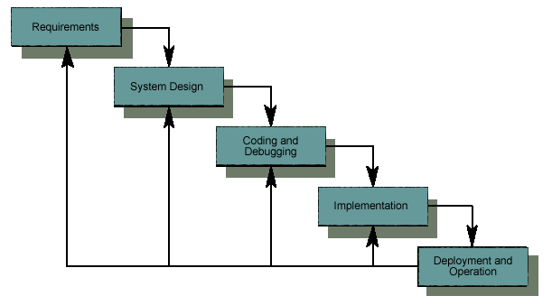
Figure 3.0 The Waterfall Model

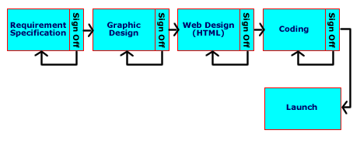
Figure3.1 The Prototyping Model

4.0 Project Planning Methodology
4.1 Project Scope

AdvanceTech is proud to present -Link, a versatile online system for prospective and enrolled students, staff, and faculty. The system will ultimately replace the handwritten/paper enrollment system that currently exists and give a large number of new features to its users. Such features for students include current course offerings and times, class registration, financial information, academic standing, and more. Features for faculty include a list of their courses and students enrolled in them, an attendance keeper for each class, and grade reporting. The system will also allow prospective students the ability to apply online, view current tuition rates, and all other relevant information about Sun University. -Link is accessible by any web browser and viewable by any connection speed. It interacts with a central database containing the entire student, staff and faculty information. With the amount of critical data being stored, the system will be accessible by username and password only. Each user will only be able to view their own personal information, excluding names and email addresses that will be accessible to all. All data being displayed will be real time coming directly from the database.

4.2 Software Functions

-Link will at a minimum provide the following functions:
- Allow any user the ability to browse course descriptions and times, explore majors, apply to the University and view any information pertaining to Sun University
- Allow registered users the ability to view their personal information after successful login with a username and password
- Allow students to drop and add classes
- Provide students with academic standing, grades, transcripts, schedules, financial information and any other relevant information.
- Allow students to pay semester bills online
- Provide class roster information to faculty for each class
- Allow faculty the ability to keep attendance for each class
- Allow faculty the ability to report each students grade at the end of the semester
- Give registered user’s ability to change personal information such as address and phone numbers.
- Ability to search the site by keywords
- Allow users with the type of Administrator the ability to add new users and maintain current information in the database such as courses descriptions, schedules, times and tuition rates.

4.23 Performance Issues

-Link will be able accessible by any browser on any platform. It will take into account any users with disabilities by including the appropriate text sizes, colors, etc. Users will also have the ability to view a text only site. -Link should incorporate a mirroring system such as RAID to ensure the protection of data. An effective backup system should also be in place for extra insurance against loss of data. In case of a failure, the system should provide detailed information where the user could find the information they were looking for.

4.4 Constraints

-Link is being built for Sun University and must comply with the budget set by the administration. The lifetime of the project will be a very detailed step by step process and therefore should not exceed the deadlines that are set. Enough time is built into each deadline to allow for some flexibility. -Link will be fully tested and proven to be efficient before going into a production environment

4.5 Project Schedule

A project schedule will need to be created to determine the length of the project, track tasks and important deadlines, and assign resources to tasks. AdvanceTech will be using Microsoft Project to create a Gantt chart, and will also include a network diagram. The Gantt chart shows a depiction of the project timeline including dates, task names, resources assigned, and the duration of the task. Figure 4.5 is a portion of the Gantt chart. The network diagram is an illustration of boxes, which are the tasks, interconnected by lines to show the sequence of project activities, and how each task is interrelated. Figure 4.6 is a figure of the network diagram. Microsoft project also allows AdvanceTech to track how much time has been spent on each task, and offers many other valuable features. Click here to open the Microsoft Project File.
Advance Tech will also have a way of their own to track what each employee is doing each day. Each employee will give a report to the project manager of the tasks they did each day. It will include what was accomplished, problems encountered, and what they plan on doing to resolve any open issues not resolved. This will ensure that the project manager is aware of all issues encountered during the development of the project. To see a screenshot of what this form will look like, see figure (Figure 4.7).

Figure 4.5 Gantt Chart
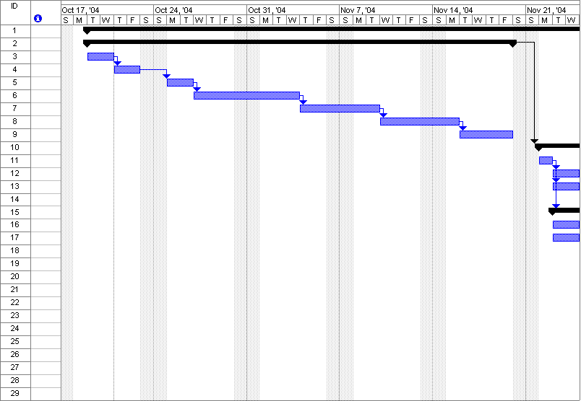

Figure 4.6 Network Diagram
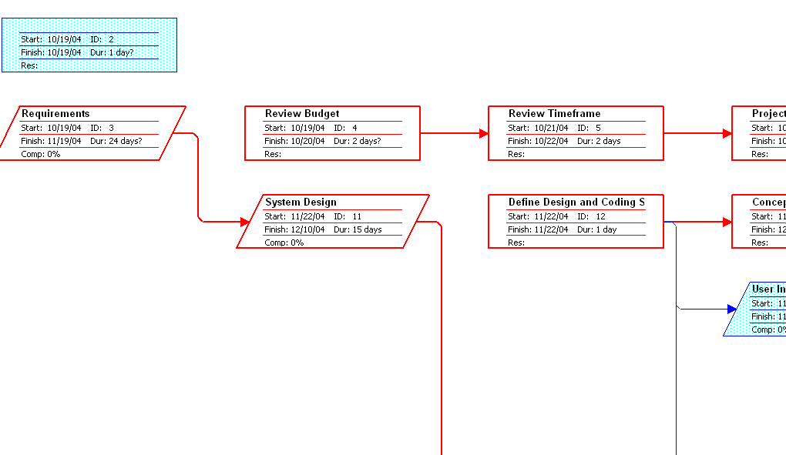
Figure 4.7 E-Link Resource Tracker
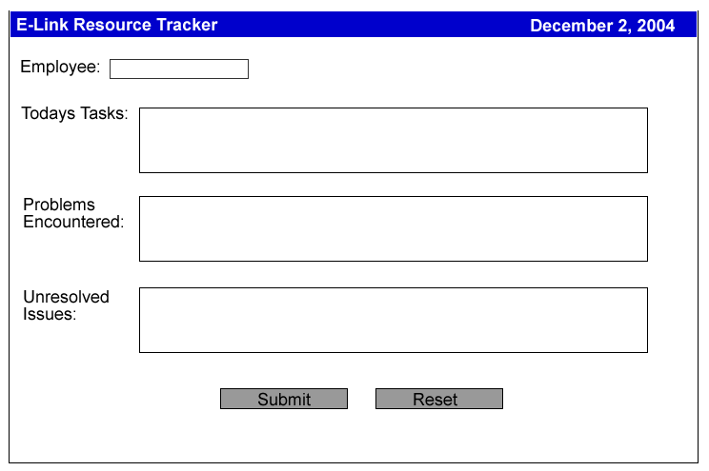

- Feasibility Analysis

This analysis will consider the feasibility of developing a web-based database application at Sun University to better manage its student registration process, provide students and facility with pertinent information from current data, and allow students to track their academic record. The analysis will focus on three central points: Economic Feasibility, Technical Feasibility, and Legal Feasibility.

5.1 Economic Feasibility

The economic feasibility of the proposed system will be based on a five year life cycle. (The five year cycle is based on the standard amount of time for hardware and software to become obsolete.)

5.1.1 Total Cost of Ownership

The team will evaluate the economic feasibility on the Total Cost of Ownership (TCO). The formula used to calculate the TCO is:
TCO = Deployment + Maintenance + Upgrade + Training

The analysis will consider cost such as:
- Hardware and Software
- Management of system, network, and storage
- Support (support contracts, training, help desk, etc.)
- Development (application and content development, testing and documentation)
5.1.2 Return on Investment
The actual feasibility will be determined by the Return on Investment (ROI) for the University. The formula used to calculate the ROI percentage is:
B = Total Benefits over 5 year period / 5
C = Total Cost of Ownership over 5 year period / 5
ROI % = ((B - C) / C)* 100

5.1.3 Short Term
The current system at Sun University relies heavily on manpower and the ability to store volumes of paperwork both on and off site. A move to a computerized system immediately reduces both of these factors. At the same time immediate cost will include the cost of new equipment, re-training staff and the development of a new system.

5.1.4 Long Term
The long term (5 year) economic effect would be the continued reduction in manpower and paper storage, as well as the reduction in scheduling mass student registrations and less time in tracking student records in the event of problems or reenrollment.

5.1.5 Intangible Cost/Benefit
Although intangible, the University would hopefully see an increase enrollment and retention of students. Intangible benefits would include resource sharing between departments of both hardware and administrative staff.
5.2 Technical Feasibility
The technical feasibility for this project will be determined at three levels; Hardware, Software and Technical Expertise. Since the actual application will have to be accessible to students and faculty, 24 hours a day, 7 days a week, it must function as a “mission critical” operation. Therefore the feasibility study must include a backup system and a disaster recovery plan.

5.2.1 Hardware
All Hardware that is purchased to be used in this project must be supported by the manufacturer or the vender. This will include online or telephone troubleshooting and the ability to return or exchange defective parts.

5.2.1.1 Computers
In order to achieve the maximum longevity from equipment, new computers will be purchased to run the application. The computers will be configured with enough CPU power, storage capacity and network capabilities to meet the projects goals.

5.2.1.2 Network
The existing network infrastructure including cabling, routers, hubs, and switches at Sun University will be used in this project as long as it is determined that the volume of network traffic can operate on the existing system. Also, the amount of increased network traffic must not interfere with users who currently are connected for unrelated information transfers.
5.2.2 Software

All software used in this project will be latest generation releases and will be readily available. The only exception to this will be the custom written application for the client/server interface.

5.2.2.1 “Out of Box”

“Out of Box” software, such as the enterprise database and operation system, will be of proven and accepted technologies supported by the manufacturer. Documentation, either hardcopy or electronic, will exist for each software.

5.2.2.2 Custom

The custom written software must be written in a programming language that the University already owns or a can obtain. The program must be fully documented with both manuals and programming comments. All source code must be owned by the University and the ability to make alterations will remain intact.

5.2.3 Expertise

Technical expertise will be managed at two levels; at the development and deployment level and a maintenance and administration level.

5.2.3.1 System Development

All expertise, used in the development of the system, will be provided by AdvanceTech. In the event additional personnel, experience, or expertise is necessary, AdvanceTech will be responsible for acquiring these services.

5.2.3.2 System Maintenance, Use, and Administration

During the initial deployment and startup period, AdvanceTech will remain responsible for system maintenance and administration. After initial deployment, the Information Technology staff will receive training to maintain and administer the system. Staff members will need to be fully trained at the time Sun University signs the final acceptance agreement for the system.

5.3 Legal Feasibility

This project must be bound by a legal framework. This framework is designed to protect the University and its students from any unnecessary repercussions as a result of the project’s implementation.

5.3.1 Regulations and Contracts

This project will be considered unfeasible if it cannot conform to all legal rules and regulations of the United States government, or to specific agreement terms and contracts with hardware and/or software vendors.
Regulations may include:
- Copyright infringement
- Licensing agreements
- Patent infringement

5.3.2 Privacy Responsibilities

This project will allow access to student records containing personal information such as: addresses, phone numbers, social security numbers and financial information. The system must be able to protect and secure all the data stored at the database level from illegal access. It will be the universities responsibility to insure faculty and administration granted access to these records is properly certified.

5.4 Additions and Modifications

Any additions and/or modifications made to the project that varies form this document must be submitted in writing, in the form of a Change Request. Change Requests will only be accepted with an authorizing signature from the project representative from Sun University. Each Change Request will be analyzed to assure it will meet all the conditions of feasibility.
Change Requests that are deemed feasible, but not necessary, will be assigned a priority level, determined by the AdvanceTech design team. No Change Request will take precedence over the materials covered in this document, unless it contains a modification to an existing functionality or if the change is considered necessary to the project and feasible according to the established guidelines.
If at any time a Change Request is deemed to be necessary, but not feasible, it will be necessary to stop the current project and all information will be presented to the project representative at Sun University for review, evaluation and direction.

5.5 Conclusion

The proposed system as described in this document will be considered feasible before any development will begin. The need to put in place a computerized system is evident, not only for the long term cost effectiveness, but also for the manner in which Sun University presents itself to prospective students in the future. The overhead involved in the current system and the mistakes caused by the ‘human factor’ will become things of the past. The future will be using technology to manage data and present information almost effortlessly.

6.0 Estimate - Hardware requirements:

The project will require two high-end servers to run the application. We recommend Dell servers because of their reputation, reliability, and support. The two models we have chosen to run the application are the PowerEdge 6650 and PowerEdge 2650 servers. The PowerEdge 6650 will be the database server, while the 2650 will run the PHP application. Both are rack mount servers, so that they can easily be added to an existing infrastructure.

PowerEdge 6650 - $24,968
- Quad Intel Xeon 2Ghz Processors
- 16GB RAM (8x2GB modules)
- RAID 5
- 5x 36GB 10K RPM Ultra 320 SCSI Hard Disks
- 3 year support from Dell
- Red Hat Enterprise Linux

PowerEdge 2650 - $5,121
- Dual Intel Xeon 2.4Ghz Processors
- 2GB RAM (4x512GB modules)
- RAID 1
- 2x 18GB 15K RPM Ultra 320 SCSI Hard Disks
- 3 year support from Dell
- Red Hat Enterprise Linux
6.1 Software requirements:

Both servers will run the Red Hat Enterprise Linux operating system, included with the systems from Dell. The operating system also includes the necessary software to run the applications as follows:

Database Server – MySQL
Web Server – Apache
Programming Language – PHP

6.1.1 Software Budget

S = Simple A = Average C = Complex

Outputs:
  - Faculty information S
  - Attendance history A
  - Personal information A

Inquiries:
  - Browse course descriptions S
  - Browse course times A
  - Explore majors S
  - View University information S
  - View academic standing A
  - View grades A
  - View transcripts A
  - View schedules A
  - View financial information C
  - Search site C

Inputs:
  - Login S
  - View personal information A
  - Apply to the University A
  - Drop/Add classes A
  - Pay bills online C
  - Report student grades S
  - Student attendance S
  - Edit personal information A
  - Administrative functions C

Files:
  - Grades S
  - Class enrollment A
  - Enrolled students A
  - Transcripts C
  - Schedules A

Interfaces:
  - Course descriptions A
  - Major descriptions A
  - Faculty information A
  - Financial information C

Simple Average Complex Total
OUTPUTS 1 * 4 2 * 5 0 * 7 14
INQUERIES 3 * 4 5 * 5 2 * 7 51
INPUTS 3 * 3 4 * 4 2 * 6 37
FILES 1 * 7 3 * 10 1 * 15 52
INTERFACES 0 * 5 3 * 7 1 * 10 31

TOTAL FUNCTION POINTS: 185

Questions (0 – Not Important / 5 – Very Important)
1. Data communications 5
2. On-line update 5
3. Distributed data/processing 5
4. Complex processing 3
5. Performance objectives 3
6. Code reusability 3
7. Tight configuration 2
8. Conversion/installation ease 3
9. High transaction rate 5
10. Operational ease 5
11. On-line inquiry/data entry 5
12. Multiple site installation 0
13. End user efficiency 5
- Facilitate change 4

TOTAL DEGREE OF INFLUENCE: 53

Adjustment Factor: .065 + (0.01 * 53) = 1.18
Final Function Point Count: 185 * 1.18 = 218
Person Months (3 People): 218 / (12 * 3) = 6

Salary: $15/hr
Hours (40hr week): 960 / person
Pay per Person: $14,400
Project Start Fee: $5,000
First Year Maintenance: $0
Total Software Development Costs: $48,200

Maintenance:
$2,500/year after the first year for basic maintenance of the existing system

Cost of new development for additional features will vary.
Figure 6.0 – Budget Summary

7.0 Capability Maturity Model Overview

It tends to be very difficult to consistently produce quality products in any organization when the software development process is poor. Many organizations relay on abilities of specific individuals to develop the software and ensure the project is on track. However, these organizations experience many problems during the life cycle of the project. When the success of a project rests solely on specific individuals, the organization has no basis for long term productivity or quality improvement. Without an enforced software process, managers are typically focused on finding solutions for the immediate problems instead of concentrating on long-term goals. Project timelines and budgets are usually exceeded because reliable estimates could not be offered and there is no objective basis for judging product quality.
In order to help organizations improve their software process, The Software Engineering Institute (SEI) began developing a process maturity framework which later evolved into the Capability Maturity Model (CMM). The CMM helped organizations gain control of their process for developing and maintaining software and made recommendations in a number of key process areas that have been shown to improve productivity. Organizations that follow a software process have shown more control over all phases of the project. Managers now had an objective basis for not only measuring the quality of the product but also the process that the product goes through. Estimates, schedules and budgets can now be based on historical performance and can be closely monitored throughout the lifecycle of the project. In general, the CMM provided organizations with a disciplined process of producing consistent products in a productive manor. The CMM helped organizations navigate the difficult path from an ad-hoc software development to a highly effective, mature software processes.

7.1 The Five Levels of the Software Process

The Capability Maturity Model improves an organizations software process using five small steps to instead of one revolutionary change. The five levels act as a scale for measuring the maturity of an organizations software process. Each maturity level consists of a set of process goals that prioritize improvement actions and stabilize different parts of the software process. As each maturity level is achieved, the organization matures and its process capacity grows. The five levels are: Initial, Repeatable, Defined, Managed, and Optimizing.
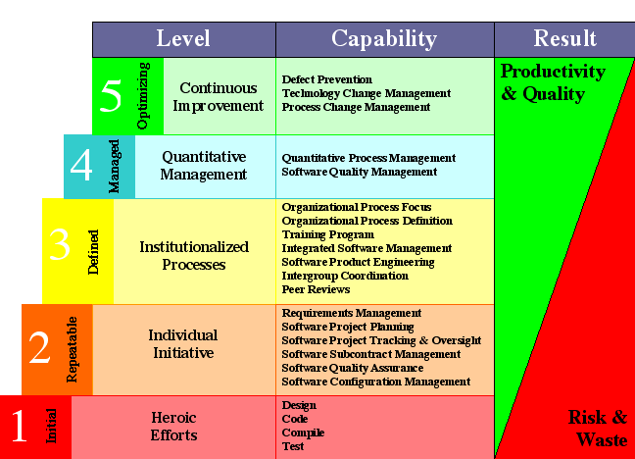
Figure 7.1 - The Capability Maturity Model
7.1.2 Level 1 – The Initial Level

Figure 7.1.2 – The Initial Level

As you can see from the graphic above, the organization does not follow a software process but instead relays on the abilities of its employees. At the initial stage, a stable environment for developing software is not usually provided and the waste far outweighs the productivity of the process and the quality of the product. Organizations at this level can be described as chaotic. When problems arise, planned procedures are usually thrown out, resorting to coding and testing. When a level one organization succeeds in a project it is usually due to the heroic efforts of competent individuals, which can not be repeated unless the same individuals are assigned to the next project.

7.1.3 Level 2 – The Repeatable Level
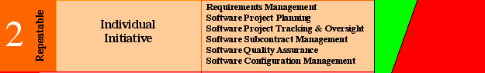
Figure 7.1.3 – The Repeatable Level

If an organization reaches the second maturity level, that organization’s software process is more organized and structured then a software process at the chaotic initial level. At this level, managing new products are based on the practices and procedures of similar products already produced. The objective at this level is to document effective management processes so they can be repeated on future products. Also at this level managers have the ability to track software costs, schedules and functionally. They work closely with subcontractors to establish a strong customer-supplier relationship and ensure the products are consistent with the customers needs.

The key process areas at a level 2 organization are concerned with establishing basic project management controls. These process areas are: Requirements Management, Software Project Planning, Software Project Tracking and Oversight, Subcontract Management, Software Quality Assurance and Software Configuration Management.
Requirements Management
Goal 1 | System requirements allocated to software are controlled to establish a baseline for software engineering and management use.
Goal 2 | Software plans, products and activities are kept consistent with the system requirements allocated to software.

The CMM for software technical report states that the purpose of Requirements Management is to establish a common understanding between the customer and the software project of the customer’s requirements that will be addressed by the software project.
Software Project Planning
Goal 1 | Software estimates are documented for use in planning and  tracking the software project.
Goal 2 | Software project activities and commitments are planned and  documented.
Goal 3 | Affected groups and individuals agree to their commitments related  to the software project.

The CMM for software technical report states that the purpose of Software Project Planning is to establish reasonable plans for performing the software engineering and for managing the software project. These plans are the necessary foundation for
managing the software project (as described in Software Project Tracking and Oversight). Without realistic plans, effective project management cannot be implemented.
Software Project Tracking and Oversight
Goal 1 | Actual results and performances are tracked against the software  plans.
Goal 2 | Corrective actions are taken and managed to closure when actual  results and performance deviate significantly from the software  plans.
Goal 3 | Changes to software commitments are agreed to by the affected  groups and individuals.

The CMM for software technical report states that the purpose of Software Project Tracking and Oversight is to establish adequate visibility into actual progress so that management can take effective actions when the software project's performance deviates significantly from the software plans.
Software Subcontract Management
Goal 1 | The prime contractor selects qualified software subcontractors.
Goal 2 | The prime contractor and the software subcontractor agree to their  commitments to each other.
Goal 3 | The prime contractor and the software subcontractor maintain  ongoing communications.
Goal 4 | The prime contractor tracks the software subcontractor's actual  results and performance against its commitments.

The CMM for software technical report states that the purpose of Software Subcontract Management is to select qualified software subcontractors and manage them effectively. It combines the concerns of Requirements Management, Software Project Planning, and Software Project Tracking and Oversight for basic management control, along with necessary coordination of Software Quality Assurance and Software Configuration Management, and applies this control to the subcontractor as appropriate.
Software Quality Assurance
Goal 1 | Software quality assurance activities are planned.
Goal 2 | Adherence of software products and activities to the applicable  standards, procedures, and requirements is verified objectively.
Goal 3 | Affected groups and individuals are informed of software quality  assurance activities and results.
Goal 4 | Noncompliance issues that cannot be resolved within the software  project are addressed by senior management.

The CMM for software technical report states that the purpose of Software Quality Assurance is to provide management with appropriate visibility into the process being used by the software project and of the products being built. Software Quality Assurance is an integral part of most software engineering and management processes.
Software Configuration Management
Goal 1 | Software configuration management activities are planned.
Goal 2 | Selected software work products are identified, controlled, and  available.
Goal 3 | Changes to identified software work products are controlled.
Goal 4 | Affected groups and individuals are informed of the status and  content of software baselines.

The CMM for software technical report states that the purpose of Software Configuration Management is to establish and maintain the integrity of the products of the software project throughout the project's software life cycle. Software Configuration Management is an integral part of most software engineering and management processes.

7.1.4 Level 3 – The Defined Level

Figure 7.1.4 – The Defined Level
When an organization reaches the defined stage, all software processes for developing and managing are well defined and documented. The organization’s technical staff begins to perform more effectively and the software process becomes more standardized. A training program is also established to ensure that the technical staff and managers know how to perform there assigned roles within the organization. According to the CMM for software technical report, the software process capability of Level 3 organizations can be summarized as standard and consistent because both software engineering and management activities are stable and repeatable. Within established product lines, cost, schedule, and functionality are under control, and software quality is tracked. This process capability is based on a common, organization-wide understanding of the activities, roles and responsibilities in a defined software process.
The key process areas at level 3 organizations are those that are concerned with implementing effective software and management processes in all projects that the organization is associated with. These key processes are: Organization Process Focus, Organization Process Definition, Training Program, Integrated Software Management, Software Product Engineering, Intergroup Coordination and Peer Reviews.

Organization Process Focus
Goal 1 | Software process development and improvement activities are  coordinated across the organization.
Goal 2 | The strengths and weaknesses of the software processes used are  identified relative to a process standard.
Goal 3 | Organization-level process development and improvement  activities are planned.

The CMM for software technical report states that the purpose of Organization Process Focus is to establish the organizational responsibility for software process activities that improve the organization's overall software process capability. The primary result of the Organization Process Focus activities is a set of software process assets, which are described in Organization Process Definition. These assets are used by the software projects, as is described in Integrated Software Management.

Organization Process Definition
Goal 1 | A standard software process for the organization is developed and  maintained.
Goal 2 | Information related to the use of the organization's standard  software process by the software projects is collected, reviewed, and  made available.

The CMM for software technical report states that the purpose of Organization Process Definition is to develop and maintain a usable set of software process assets that improve process performance across the projects and provide a basis for cumulative, long-term benefits to the organization. These assets provide a stable foundation that can be institutionalized via mechanisms such as training, which is described in Training Program.

Training Program
Goal 1 | Training activities are planned.
Goal 2 | Training for developing the skills and knowledge needed to  perform software management and technical roles is provided.
Goal 3 | Individuals in the software engineering group and software-related  groups receive the training necessary to perform their roles.

The CMM for software technical report states that the purpose of Training Program is to develop the skills and knowledge of individuals so they can perform their roles effectively and efficiently. Training is an organizational responsibility, but the software projects should identify their needed skills and provide the necessary training when the project's needs are unique.

Integrated Software Management
Goal 1 | The project's defined software process is a tailored version of the  organization's standard software process.
Goal 2 | The project is planned and managed according to the project's  defined software process.

The CMM for software technical report states that the purpose of Integrated Software Management is to integrate the software engineering and management activities into a coherent, defined software process that is tailored from the organization's standard software process and related process assets, which are described in Organization Process Definition. This tailoring is based on the business environment and technical needs of the project, as described in Software Product Engineering. Integrated Software Management evolves from Software Project Planning and Software Project Tracking and Oversight at Level 2.

Software Product Engineering
Goal 1 | The software engineering tasks are defined, integrated, and  consistently performed to produce the software.
Goal 2 | Software work products are kept consistent with each other.

The CMM for software technical report states that the purpose of Software Product Engineering is to consistently perform a well-defined engineering process that integrates all the software engineering activities to produce correct, consistent software products effectively and efficiently. Software Product Engineering describes the technical activities of the project, e.g., requirements analysis, design, code, and test.

Intergroup Coordination
Goal 1 | The customer's requirements are agreed to by all affected groups.
Goal 2 | The commitments between the engineering groups are agreed to by  the affected groups.
Goal 3 | The engineering groups identify, track, and resolve intergroup  issues.

The CMM for software technical report states that the purpose of Intergroup Coordination is to establish a means for the software engineering group to participate actively with the other engineering groups so the project is better able to satisfy the customer's needs effectively and efficiently. Intergroup Coordination is the interdisciplinary aspect of Integrated Software Management that extends beyond software engineering; not only should the software process be integrated, but the software engineering group's interactions with other groups must be coordinated and
controlled.

Peer Reviews
Goal 1 | Peer review activities are planned.
Goal 2 | Defects in the software work products are identified and removed.

The CMM for software technical report states that the purpose of Peer Reviews is to remove defects from the software work products early and efficiently. An important corollary effect is to develop a better understanding of the software work products and of the defects that can be prevented.

7.1.5 Level 4 – The Managed Level

Figure 7.1.5 – The Managed Level

As an organization moves up to level 4, it has already seen the correlation between the software process and the dramatic change in productivity. At this stage, productivity and quality are measured and recorded in order to improve in both areas on future products. An organizational-wide software process database is used to collect and analyze the well-defined and consistent measurements that were recorded. Once an organization reaches level 4, the development of all products can be referred to as predictable because the development of previous products were recorded and analyzed.
The key process areas at level 4 focus on the overall, company-wide understanding of the software process. The two key process areas at this level are: Quantitative Process Management and Software Quality Management.
Quantitative Process Management
Goal 1 | The quantitative process management activities are planned.
Goal 2 | The process performance of the project's defined software process is  controlled quantitatively.
Goal 3 | The process capability of the organization's standard software  process is known in quantitative terms.

The CMM for software technical report states that the purpose of Quantitative Process Management is to control the process performance of the software project quantitatively. Software process performance represents the actual results achieved from following a software process. The focus is on identifying special causes of variation within a measurably stable process and correcting, as appropriate, the circumstances that drove the transient variation to occur. Quantitative Process Management adds a comprehensive measurement program to the practices of Organization Process Definition, Integrated Software Management, Intergroup Coordination, and Peer Reviews.
Software Quality Management
Goal 1 | The project's software quality management activities are planned.
Goal 2 | Measurable goals for software product quality and their priorities  are defined.
Goal 3 | Actual progress toward achieving the quality goals for the software  products is quantified and managed.

The CMM for software technical report states that the purpose of Software Quality Management is to develop a quantitative understanding of the quality of the project's software products and achieve specific quality goals. Software Quality Management applies a comprehensive measurement program to the software work products described in Software Product Engineering.

7.1.6 Level 5 – The optimizing Level
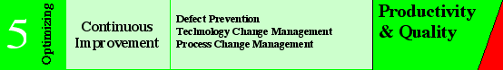
Figure 7.1.6 – The Optimizing Level

When an organization reaches level 5 they are focused on continually improving their currently optimized software process. At level one, the organization was at a chaotic state of development, but now the organization has means to identify weaknesses and prevent against the occurrence of defects. Estimates and cost benefit analysis can now be effectively determined, which in turn increases productively and reduces waste. At this level, organizations can be referred to as continuously improving, by means of both existing processes and innovations using new technologies and methods.

The key process areas at level 5 address to the issues that an organization must implement in order to achieve continuous and measurable software process improvement. The key process areas for level 5 are: Defect Prevention, Technology Change Management and process change management.

Defect Prevention
Goal 1 | Defect prevention activities are planned.
Goal 2 | Common causes of defects are sought out and identified.
Goal 3 | Common causes of defects are prioritized and systematically  eliminated.

The CMM for software technical report states that the purpose of Defect Prevention is to identify the causes of defects and prevent them from recurring. The software project analyzes defects, identifies their causes, and changes its defined software process, as is described in Integrated Software Management. Process changes of general value are transitioned to other software projects, as is described in Process Change Management.

Technology Change Management
Goal 1 | Incorporation of technology changes are planned.
Goal 2 | New technologies are evaluated to determine their effect on quality  and productivity.
Goal 3 | Appropriate new technologies are transferred into normal practice  across the organization.

The CMM for software technical report states that the purpose of Technology Change Management is to identify beneficial new technologies (i.e., tools, methods, and processes) and transfer them into the organization in an orderly manner, as is described in Process Change Management. The focus of Technology Change Management is on performing innovation efficiently in an ever-changing world.

Process Change Management
Goal 1 | Continuous process improvement is planned.
Goal 2 | Participation in the organization's software process improvement  activities is organization wide.

The CMM for software technical report states that the purpose of Process Change Management is to continually improve the software processes used in the organization with the intent of improving software quality, increasing productivity, and decreasing the cycle time for product development. Process Change Management takes the incremental improvements of Defect Prevention and the innovative improvements of Technology Change Management and makes them available to the entire organization.

7.2 The Development Process for -Link

In order to maintain a structured software and management process, AdvanceTech will keep in alignment with the key process areas of the Repeatable Level. The formation of our company’s software process to develop -Link will be based on similar products that our company has developed in the past. Our company will document all steps in the development of -Link so they can be referred to for future upgrades or revisions to the -Link system.

7.2.1 Requirements Management

Our company understands that Requirements Management is an important step in the development of -Link. AdvanceTech will hold several meetings with University representatives to ensure all requirements are discussed and there is a common understanding between our company and the University.

7.2.2 Software Project Planning

Before any member of our team begins to write the code for -Link, a thorough plan will be discussed and agreed upon by all team members. It is imperative to the quality of our product that an effective project plan be created before development begins.

7.2.3 Software Project tracking and Oversight

AdvanceTech will track all costs, schedules and functionally to ensure the product is delivered on time and within budget. Any deviations from the initial contract will be discussed in a meeting with the University.

7.2.4 Software Subcontract Management

Sun University has subcontracted the project for -Link Information System to AdvanceTech Enterprises. The development team will work directly with representatives of the University to ensure the product specifications meet the needs of the students.

7.2.5 Software Quality Assurance

On every product our company develops, quality assurance is our number one goal. AdvanceTech will ensure consistent quality through out the development process of the -Link system. Periodically we will ask the representatives at Sun University to look over the part of the system that was completed and evaluate the overall functionally and quality.

7.2.6 Software Configuration Management

AdvanceTech understands that software configuration management is an integral part of the development and management process. We will make every effort to maintain the integrity of -Link through out the life cycle of the product.

8.0 Risk Management
The team at AdvanceTech understands that no project comes without risk. We also know risk can be diminished with proper analysis and contingency planning. For the purpose of the -Link project we will define risk as: the possibility of an act or event occurring that would have an adverse effect on; one or more of the projects operational areas and/or create a financial loss for Sun University or AdvanceTech.

8.1 Risk Evaluation Process
The evaluation and management of risks to the -Link project will be an ongoing process (Figure 8.1). Weekly project meetings as well the project personnel’s daily activity will be necessary to manage risks associate with -Link. The project manager and system administrator will be responsible for storing all risk information and assign responsibility to the appropriate personnel involved in the corrective action. The evaluation process will use the following steps:
- New risk is identified
- Risk attributes are assigned (probability, impact, and timeframe).
- Contingency plan or corrective action is allocated.
- Risk Information Form is completed.
- Risk information, attributes, and corrective action are entered into a database.
- Risks are prioritized by the Project Manager, System Administrator, and Sun University project representative.
- Project Manager, System Administrator, and Sun University project representative will review and reprioritized risks on a weekly basis.

The risk management process will consist of six key elements:
- Identification of risks – discovering and documenting risks on an ongoing basis.
- Analysis of risks – estimating the probability, impact, and timeframe of risks.
- Planning risks – developing an action plan should the risk be realized.
- Tracking risks – monitoring the status of the risks and any actions taken.
- Controlling risks – taking corrective action
- Communication of risks – sharing awareness of activity in the five previous elements and also introducing new risk threats as they arise.
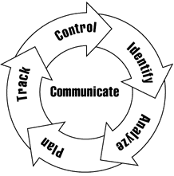
Figure 8.1 – Risk Management Process

Any and all identified risks should be brought to the attention of the Project Manager. The Project Manager will be responsible for entering the risk assessment into the system and communicating the risk to the rest of the team. No action should be taken to mitigate any risk unless it is entered into the database fully documented.
8.2 Prioritization Assignment
Attributes associated with risk need to be prioritized, based on the effect they could possibly have on the overall project. A combination of the attributes’ level of severity will aid the Project Manager in the determination of the threat to the project. The following tables will assign the criteria for evaluating the attributes of Impact, Probability, and Timeframe.

Impact
Identifier | Level | Description
1 | Catastrophic | Will cause hardware or software to become non-operational
2 | Critical | Reduction in performance – will cause project delays
3 | Marginal | Slight reduction in performance –no effect on project milestones
4 | Negligible | No reduction in performance – possible nuisance problem
Table 8.2.1
Probability
Identifier | Level | Chance of Occurrence
1 | Very High | 76-100%
2 | High | 51-75%
3 | Moderate | 26-50%
4 | Low | 11-25%
5 | Very Low | 1-10%
Table 8.2.2
Timeline
Identifier | Level | Time until action is taken
1 | Imminent | Less then one week
2 | Near-Term | One to two weeks
3 | Mid-Term | While project is being developed
4 | Far-Term | Up until project deployment
5 | Very Far-Term | After project deployment
Table 8.2.3
8.3 Baseline Risk Evaluation
Risks that have been identified, as of the writing of this document, will serve as a baseline for the risk management system. This list will be modified as new risks are identified and during weekly project meetings. The following subtopics provide a brake down of the initially identified risks as they are associated to certain categories.

8.3.1 Business Impact
Pressman defines the Business Impact as - Risks associated with constraints imposed by management or the marketplace.

Vulnerability (Business Impact) | Possible Effect | Plan of Action
Natural Disaster - Fire, Flood, etc. | - Loss of network  - Loss of computerized service  - Loss of data | - Create Disaster Recovery Plan  - Define Data Backup Policy  - Purchase Insurance from a third party
Inadequate or loss of funding | - Project would be Stopped  - Project definition would be reduced | - Insure all budget and financial needs are met  - Allow adequate maintenance budget
Misuse of Equipment | - Interruption of Services  - Additional network traffic  - Equipment failure  - Loss of public confidence | - Enforce equipment use policies  - Limit to authorized users  - Authenticate all users  - Install virus protection software
Theft of Equipment | - Interruption of Services  - Loss of data  - Loss of public confidence | - Secure all equipment in locked environment  - Purchase Insurance from a third party
Table 8.3.1

8.3.2 Customer Related
Pressman defines the Customer Characteristics as - Risks associated with the degree to which the customer and the developer’s ability to communicate with the customer in a timely manner

Vulnerability (Customer Related) | Possible Effect | Plan of Action
System Not Utilized | - Elimination of E-Link system  - Loss of long-term funding  - Personnel termination | - Public communication  - Provide training for end users  - Provide help documentation to end users  - Create easy to use functionality  - Utilize handicap accessibility procedures
Loss of Public Confidence | - Elimination of E-Link system  - Loss of long-term funding  - Personnel termination  - System not utilized | - Maintain data integrity  - Secure personal information  - Anti-virus protection measures  - Communicate with end users
Table 8.3.2
8.3.3 Process
Pressman defines the Process as - Risks associated with the degree to which the software process has been defined and is followed by the development organization.

Vulnerability (Process) | Possible Effect | Plan of Action
Data Integrity | - Loss of public confidence  - Legal actions  - Loss of funding  - Elimination of E-Link system | - University staff traning  - Anti-virus software  - Setup firewall  - Follow back-up routines  - Secure equipment  - Follow all maintenance procedures
Unauthorized users or Hackers | - Loss of public confidence  - Legal actions  - Loss of funding  - Personal information jeopardized | - Conduct routine security checks on system  - Setup firewall  - Backup data
Table 8.3.3
8.3.4 Technology Risk
Pressman defines the Technology to be built as - Risks associated with the complexity of the system to be built and the “newness” of the technology that is packaged by the system.
Vulnerability (Technology) | Possible Effect | Plan of Action
Network unable to support traffic | - Elimination of E-Link system  - Loss of long-term funding  - Personnel termination  - System not utilized | - Insure network integrity  - Define network speed requirements  - Replace obsolete equipment  - Modify router software
Obsolete Equipment | - Slow or interrupted network services  - Loss of public confidence  - System not utilized | - Determine life cycle of hardware and software  - Plan for 5 years until obsolescence  - Replace outdated equipment
Interruption in Network Services | - Public would not utilize system  - Data send and receive would be slowed down | - Insure network speeds including internet connection  - Insure virus protection software is in place and functioning
Table 8.3.4

8.3.5 Human Resources
Pressman defines the Staff size and experience as - Risk associated with the overall technical and project experience of the software engineers who will do the work.
Vulnerability (Human Resources) | Possible Effect | Plan of Action
Turnover of AdvanceTech personnel | - Reduction in technical expertise  - Loss of confidence/morale  - Failure to meet deadlines | - Knowledge base for all phases of project  - Reasonable working conditions  - Documentation
Turnover of university personnel | - Reduction in trained personnel  - Loss of expertise  - Loss of confidence/morale | - Ample staffing  - Cross training  - Shared responsibilities
Organizational Conflict | - Loss of project personnel  - Loss of funding  - Interruption of system obligations | - Continuous communication with all team members  - Weekly feed back to higher management  - All work documented
Table 8.3.5
8.4 Risk Matrix
Using the previous defined identifier values for the risk attributes Table 9.4 represents the overall threat to the system, by the identified vulnerabilities. The severity of the threat is determined by rating the impact, probability and timeline. The vulnerabilities can then be prioritized based on their value. In some cases priority levels may be equal and the Project Manager will assign priority based on experience and expertise.

Risk Matrix for Baseline Risk Vulnerability List

Identified Risk | Impact | Probability | Timeframe
Natural Disaster - Fire, Flood, etc. | 2 | 5 | 1
Inadequate or loss of funding | 1 | 3 | 1
Misuse of Equipment | 2 | 2 | 5
Theft of Equipment | 3 | 4 | 2
Software not Utilized | 1 | 4 | 5
Loss of Public Confidence | 2 | 5 | 5
Data Integrity | 1 | 3 | 1
Unauthorized users or Hackers | 3 | 4 | 2
Network unable to support traffic | 2 | 4 | 2
Obsolete Equipment | 4 | 5 | 1
Interruption in Network Services | 1 | 3 | 3
Turnover of AdvanceTech personnel | 2 | 4 | 1
Turnover of university personnel | 2 | 3 | 2
Organizational Conflict | 1 | 2 | 1
Table 8.4

8.5 Prioritized Risk Responsibilities
Based on the Risk Matrix (Table 9.4) we are able to place priority assignments to the vulnerabilities (Table 9.5).

Priority | Identified Risk
1 | Organizational Conflict
2 | Inadequate or loss of funding
3 | Data Integrity
4 | Interruption in Network Services
5 | Turnover of AdvanceTech personnel
6 | Turnover of university personnel
7 | Natural Disaster - Fire, Flood, etc.
8 | Network unable to support traffic
9 | Misuse of Equipment
10 | Theft of Equipment
11 | Unauthorized users or Hackers
12 | Software not Utilized
13 | Obsolete Equipment
14 | Loss of Public Confidence
Table 8.5

Note: This list will be continuously modified both on an ongoing basis by the project staff and during weekly meetings between AdvanceTech and Sun University representatives.

8.6 Options
After the risks have been defined and prioritized, there are several options available to us (as defined by NIST – National Institute of Standards and Technology).

- Risk Assumption – To accept the potential risk and continue operating the system or to implement controls to lower the risk to an acceptable level.

- Risk Avoidance – Top avoid the risk by eliminating the risk cause and/or consequence.

- Risk Limitation – To limit the risk by implementing controls that minimize the adverse impact of a threat’s exercising a vulnerability.

- Risk Planning – To manage risk by developing a risk mitigation plan that prioritizes, implements, and maintains controls.

- Research and Acknowledgement – To lower the risk of loss by acknowledging the vulnerability or flaw and researching controls to correct the vulnerability.

- Risk Transference – To transfer the risk by using other options to compensate for the loss, such as purchasing insurance.

9.0 Software Quality Assurance

9.1 Introduction
The following section provides an overview of E-Link's Software Quality Assurance plan (SQA) that is used in our projects.

  - Scope and intent of SQA activities
E-Link's SQA plan is designed so that our customers receive excellent support with our software. It is designed so that if any problems are to arise we can quickly and efficiently solve the problem.

  - SQA organizational role
Our SQA team interacts directly with our software engineers. Once the problem is brought to our attention and is identified, we direct our customers to the correct team to handle any further problems.

  - 9.2 SQA Tasks

  - Work products and documentation
After the problem has been resolved, if it impacts the way the software functions, the proper documentation will be reviewed and edited, or new documentation will be written and submitted to the user.

  - Standards, Practices and Conventions (SPC)
For each problem that may arise with the software, the user or administrator will submit a problem report through a form on our company's website. They will be asked for their customer information, the product information, and a description of their problem. Once we receive the problem report, we will contact the user if there is any additional information. If not the report is forwarded to the correct department, and they will contact the customer and try to solve the problem.

  - SQA Resources
Our SQA resources consist of an on-line system for tracking problem reports from our users that help us to identify who they are and what software application they are using by asking for their customer and product information, a team of quality assurance agents that review these requests as they are made, and our actual software engineers that interact with the users to solve these problems.

  - Reviews and Audits

  - Generic Review Guidelines
After the problem has been resolved with our users, all the information on what caused the problem to occur, what error was generated as a result of the problem, and how the error was corrected is recorded into a report for future use.
    - Conducting a Review
During the process of a review, all communication between the user and E-Link concerning the problem is examined, how the user responded to our support, the impact the problem caused on behalf of the user, and how long it took for the problem to be resolved.
    - Roles and Responsibilities
The responsibilities of each department during a review is our quality assurance agents report the initial contact made with the client concerning their problem, the software engineers that worked with the client report their results, and the management teams submit any reports concerning the problem that were generated as a result of finding the solution.
    - Review work products
As a result of reviews, corrective reports are generated for reference and review by E-Link along with new user documentation on the existing software.

    - Formal Technical Reviews
After all the information has been gathered by E-Link on how the problem was resolved, a formal technical review (FTR) is generated and stored for future use and reference.
    - SQA Audits
At the end of the SQA process, an audit is made by contacting the client and seeing that their problem was resolved quickly and to their liking, and if not how we can be of better service in the future.

  - Problem Reporting and Corrective Action/Follow-up

  - Reporting mechanisms
After the problem has been resolved and a FTR has been produced, a follow-up report is produced which is then reviewed by the managers of software engineering teams and the company management team.

  - Responsibilities
After the follow up report has been reviewed, the company management team and/or the software engineering team takes corrective actions based on the follow-up report so that future problems can be avoided.

  - Data collection and evaluation
Any important information from these follow-up reports are stored on file for easy reference so that in future projects they can be referenced by the development teams to understand past problems and avoid future similar problems.

  - Software Process Improvement Activities (SPI)

  - Goal and objectives of SPI
The goal of our SPI Activities is to guarantee that any problems that arise in our software are quickly and correctly resolved, and to prevent future problems with our existing software or other projects.
  - SPI tasks and responsibilities
Before a new project is started and during the design stage of the software, past projects are examined and their FTRs are reviewed by the management teams of the software engineers and by the software engineers themselves so that problems that have occurred in the past can be prevented from occurring in the current project, or possible problems that could occur based on similar past experiences can be avoided.

10.0 Requirements Analysis Process

10.1 Elicitation

One of the most important steps in requirements analysis is getting the information from the customer. As we have previously stated in this document, AdvanceTech will schedule several meetings with representatives from Sun University. Every team member will be present in these meetings in addition to several stakeholders from Sun University. This will ensure that everyone in our team understands the business processes and the requirements for the -Link Information System. These meeting will also establish a forum for all everyone to be heard, for issues to be worked out and for resolutions to be defined that meet the needs of all parties. AdvanceTech will then analyze the resolutions of these meetings and define a detailed requirements analysis process.

10.2 Types of Requirements
10.2.1 Physical Location
The -Link Information system will reside on the server specified in the hardware section of this document. The server that houses the system will be placed in a locked room on the Sun University campus that can only be accessed by the system administrator. This room has also been designed to ensure optimal temperatures and environmental conditions.
10.2.2 Interfaces
The input and output of the -Link information system will in the most part, reside on the dedicated server. As stated before, access to any information on the -Link server will require the use of a username and password. Upon approval of that information, the user will then be allowed to access the content available within the level of their clearance. Therefore, the only need for the information to be available outside of the system would be when a student wanted their schedule or grades sent to their e-mail.
AdvanceTech is very aware that users will have different levels of computer knowledge. Therefore, the -Link Information system will have a very user friendly design. Many pages of the information system will be created using text fields. This will allow the user to simply enter there unformatted text into the field and not have to worry about formatting the data in any way. If data needs to be in a special format on any part of the -Link system, it will be handled by functions within the systems software.
AdvanceTech also understands that users connect to the Internet at different speeds. In order to make the system available for all students, -Link will be designed so that a user can access it over any medium. Some examples of different types of mediums include, but are not limited to: dial-up, DSL, Cable, Satellite, T1 and T3.
10.2.3 Users and Human Factors
The -Link Information System will allow access to students, faculty, staff and system administrators. Each user will be required to sign in with their provided username and password. Once the user signs in, the system will know who the user is and what permissions that user has. For example, University students have the ability to access most information but only system administrators have the ability to make changes to the content.
AdvanceTech understands that the -Link system must be very user friendly because the system is going to be new to all users. Our company knows that the users will be from all skill levels and kept and designed the information system according to their needs. Since the system will be user friendly, minimal training will be required. However, if a user needs additional help, they can find answers to their questions through online-tutorials and user-guides.
Misuse of the -Link Information system will be very difficult. Every user is required to log in with a user name and password, and the system automatically sets restrictions on specified areas. The only misuse of the system can occur if a users password is obtained and misused by another individual.
10.2.4 Functionality
AdvanceTech is proud to present -Link, a versatile online system for prospective and enrolled students, staff, and faculty. The system will ultimately replace the handwritten/paper enrollment system that currently exists and give a large number of new features to its users. Such features for students include current course offerings and times, class registration, financial information, academic standing, and more. Features for faculty include a list of their courses and students enrolled in them, an attendance keeper for each class, and grade reporting. The system will also allow prospective students the ability to apply online, view current tuition rates, and all other relevant information about Sun University.
The -Link Information system has several modes of operation. The three main types of users will be: Students, Faculty/Staff, and System Administrators. Students will have the least access to the system. They will have the ability to browse course descriptions and times, explore majors, apply to the University and view any information pertaining to Sun University. In addition they can: drop and add classes, view their personal information, pay their semester bill and search the site by keywords. A Faculty/Staff member will have a little greater access by having the ability to keep attendance for each class, report each student’s grade at the end of the semester and view information about their students. System administrators will have the greatest access to the system. They will have the ability to add new users and maintain current information in the database such as courses descriptions, schedules, times and tuition rates.
Since the -Link Information System will need new features as time progresses, the system will be made as flexible as possible to allow for these features. However, since the -Link system is very complex, any enhancements are to be made by AdvanceTech Enterprises.
In an effort to ensure a satisfying user experience when using the -Link system, images and java applets will be kept to a minimum. Response time is a crucial component in the usability of the system and our company wants to ensure that response time is kept to a minimum for every type medium.
10.2.5 Documentation
Due to the relatively large scope of this project, detailed documentation will be need through out all phases of the project. At every stage, AdvanceTech will document what the requirements are for that stage and how those requirements are going to influence the overall design of the system. The majority of the documentation will be completed prior to the implementation of the system and may include the use of tables, figures and Gantt charts.
AdvanceTech feels it is important to ensure that the documentation can not only be viewed by our team members but also the representatives of Sun University. Therefore, the documentation will be made available in both, paper and electronic format. The use of a searchable electronic document in addition to a paper format will allow for easy viewing and quicker approval.
10.2.6 Data
As stated earlier, the -Link Information system will ensure a user friendly interface by providing users with forms and textboxes. The use of these input devices will allow the user to simply enter pain unformatted text. If the text needs to be formatted in any way, the system will have internal functions to handle these conversions. Any data that needs to be displayed will be output using a variety of web languages. Some of these languages may include but are not limited to, HTML, JavaScript, PHP, ASP and PERL.
Since the data in the -Link information system is to be used by a University, it must be extremely accurate and free from errors. This will be accomplished using several internal functions that will check the data and send the appropriate error message if the data is not accurate. Similar functions will also be used to calculate and round the results of a data set to the second degree of precision. For example, if a student requests a GPA prediction, the system will input the data from the user, calculate that data, and output the score to the second decimal place.
The amount of data that can flow through the system on any given day will vary according to the amount of users logged onto the system. For example, during an average weekday, hundreds of users might be logged onto the system at the same time and will use the system for an undetermined amount of time. However, during weekends and holidays, the through put of the system might be significantly less due to a smaller amount of users logged on.
Since the -Link Information System will be used to keep records pertaining to students, the data will be stored for a minimum of 5 years. At the end of five years, the data can be removed by the system administrator or left in place for undetermined amount of time.
10.2.7 Resources
The project will require two high-end servers to run the application. We recommend Dell servers because of their reputation, reliability, and support. The two models we have chosen to run the application are the PowerEdge 6650 and PowerEdge 2650 servers. The PowerEdge 6650 will be the database server, while the 2650 will run the PHP application. Both are rack mount servers, so that they can easily be added to an existing infrastructure.
During the implementation phase, AdvanceTech will require the use of Sun University’s networking department in addition to full access to their current network. Our development team will possess the knowledge needed to fully integrate the new system to the network that is currently in place. In addition, the team will have excellent communication skills and will work together to meet all requirements specified by Sun University representatives.
The physical space required by the system will be minimal. The server that houses the system will be placed in a locked room on the Sun University campus that can only be accessed by the system administrator. This room has also been designed to ensure optimal temperatures and environmental conditions. The primary environmental concern for the -Link system is to ensure an uninterrupted power supply for the server. This will be accomplished by the use of a backup generator which is already in place at Sun University.
10.2.8 Security
Due to the sensitive nature of the data that can be accessed by the -Link system, security is of vital importance. Access to the information on the system will be carefully controlled and protected. As stated before, access to any information on the -Link server will require the use of a username and password. Upon approval of that information, the user will then be allowed to access the content available within the level of their clearance. Through this measure of security, a user’s data will be hidden from other users with the same level of clearance. The only possible security risk that can occur is if a user’s password is compromised. This situation will be controlled by allowing the user to change their password at any given time.
Since the -Link system is a web-based software solution, it does not need to be concerned with isolating users programs. The network permissions that are currently in place will handle this area of security.
In the event that the entire system goes down, the University can use the backup system that will be updated on a daily basis. Copies of the backed up material should be stored in separate location as a precaution against fire, damage or theft.

10.3 Quality Assurance
10.3.1 Reliability
The -Link information system needs to be very reliable so users can obtain their information when it is needed. To ensure reliability, AdvanceTech chose to use several hardware devices. The server that the -Link Information System resides on will be backed up on a daily basis and those backups will be taken to an offsite location once a week. In addition, the server will be connected to a backup generator to ensure constant reliable power.
10.3.2 Availability
The -Link Information System was designed to be available for students 24 hours a day and 7 days a week. Any authorized user with a username, password and internet connection can log onto the system.
10.3.3 Maintainability
During the testing phases of the Information System project, AdvanceTech fixed any bugs that they found. However, it is not unusual for additional bugs to be discovered after implementation. Therefore, our company designed the system to accept upgrades and patches whenever needed.
For each problem that may arise with the software, the user or administrator will submit a problem report through a form on our company's website. They will be asked for their customer information, the product information, and a description of their problem. Once we receive the problem report, the appropriate department will contact the customer and try to solve the problem. If an error in the system is detected, a patch will be installed that will correct the problem and prevent any similar problems in the future.
10.3.4 Security
Since the security of personal information is of an utmost concern, each student will be given a unique username and password. That information will be sent over a secure connection and checked for validity. Once the authentication process is complete, only then will the user have access to the system.
At the time of system implementation, all faults will be reduced to a minimum or prevented completely. However, if a fault does occur, a problem report should be immediately sent through a form on our company's website. Our maintenance team will promptly respond with a solution to the problem.

11.0 Network Diagram

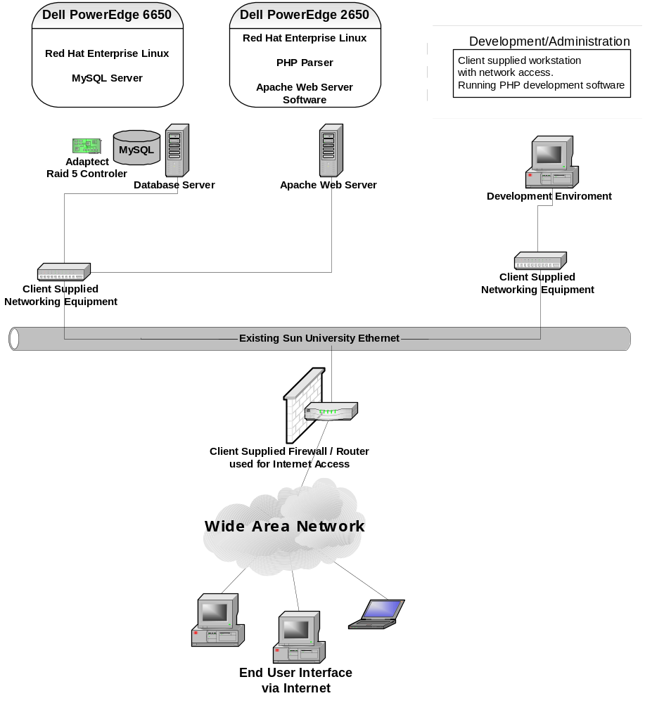

Figure 11.0 – Network Diagram

12.0 Use Case Diagrams
Advance Tech will be using Use Case diagrams to define use cases for each type of user. This type of diagram is used to denote the major functionality of the system, and who is able to interact with each part of the system. Below are use cases for the general user, student, faculty, and administrator.
12.1 General User Use Case
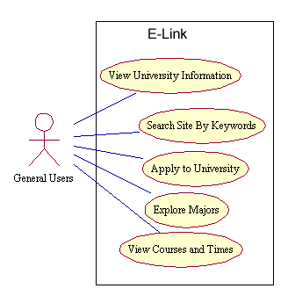
Figure 12.1 General User Use Case

12.2 Student Use Case
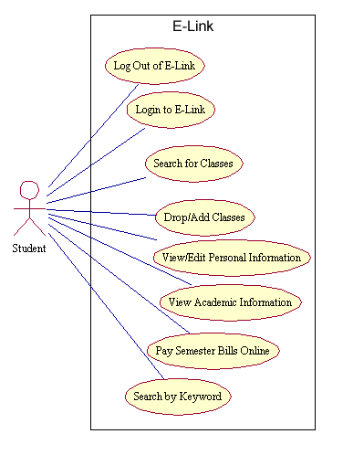
Figure 12.2 Student Use Case

12.3 Faculty Use Case
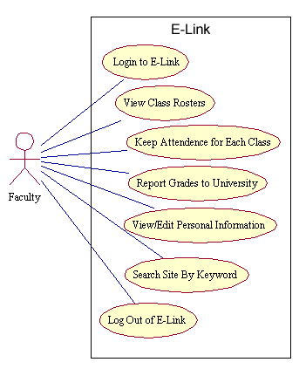
Figure 12.3 Faculty Use Case

12.4 Administrator Use Case
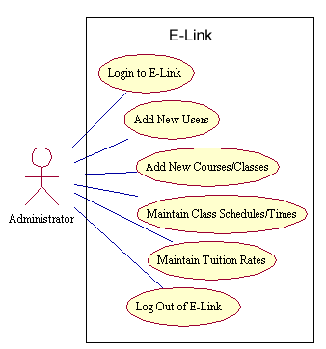
Figure 12.4 Administrator Use Case

13.0 Activity Diagrams
AdvanceTech will also be using Activity Diagrams to help design -Link conceptually. Activity diagrams help visualize the activities of the system for the stakeholders and the developers. Below are five activity diagrams for activities defined in the scope.

13.1 Pay Semester Bill Activity Diagram
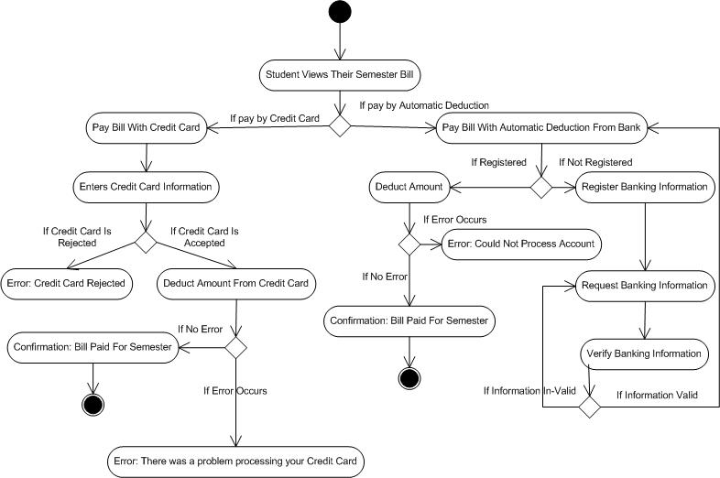
Figure 13.1Pay Semester Bill Activity Diagram

13.2 Login Activity Diagram
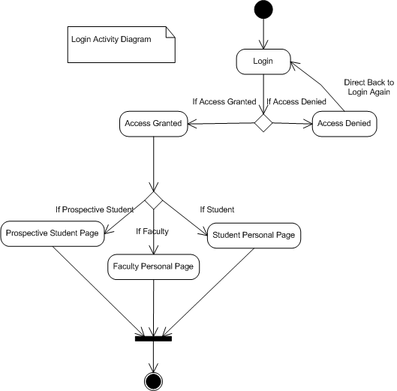
Figure 13.2 Login Activity Diagram

13.3 Instructor Views Class Roster Activity Diagram
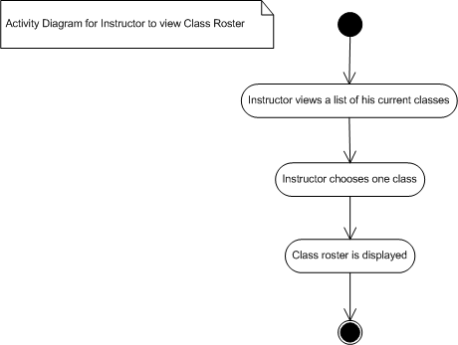
Figure 13.3 Instructor Views Class Roster Activity Diagram

13.4 Drop/Add Activity Diagram
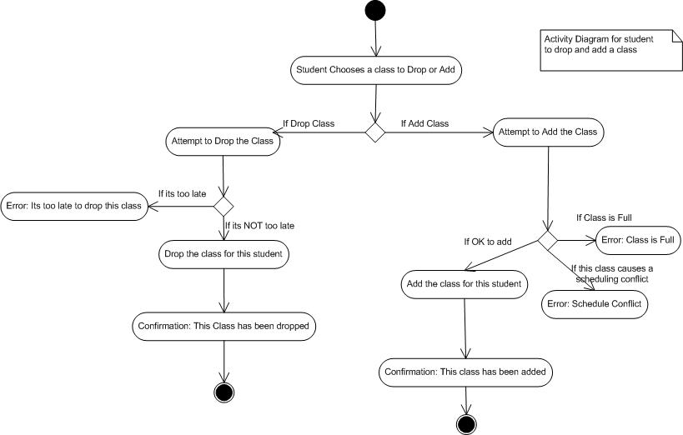Figure 13.4 Drop/Add Activity Diagram

13.5 Administrator Adds a Class Activity Diagram
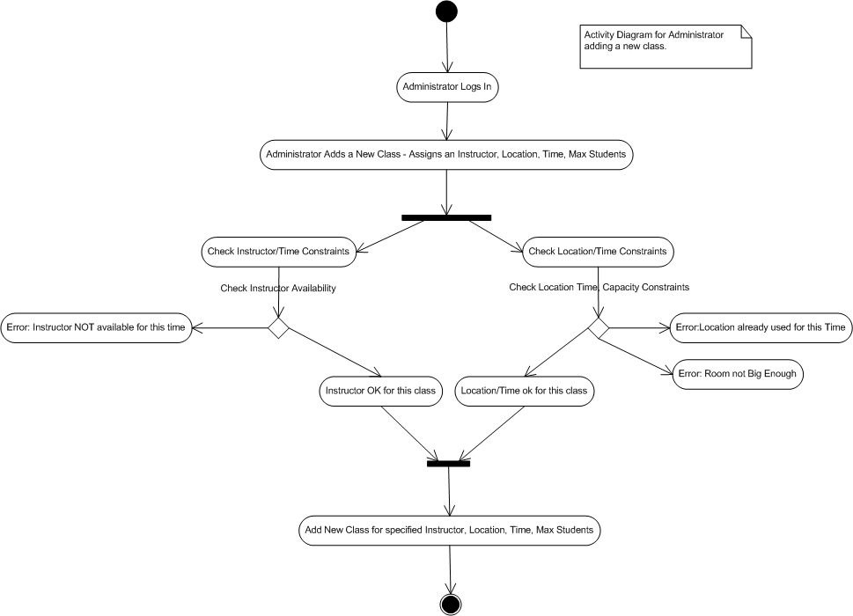
Figure 13.5 Administrator Adds a Class Activity Diagram

20.0 References
Paulk, Mark C., (1996). A Comparison of the ISO 9001 and the Capability Maturity
Model for Software.
Technical Report CMU/SEI-94-TR-12ESC-TR-94-12
Pittsburg, PA: Carnegie Mellon University. Retrieved September 21, 2004
http://www.sei.cmu.edu/publications/documents/94.reports/94.tr.012.html

Curtis, Bill, (1993). Capability Maturity Model for Software.
Technical Report CMU/SEI-93-TR-024ESC-TR-93-177
Pittsburg, PA: Carnegie Mellon University. Retrieved September 20, 2004
http://www.sei.cmu.edu/publications/documents/93.reports/93.tr.024.html

McGregor, John D., (2001). Testing a Software Product Line.

TECHNICAL REPORT CMU/SEI-2001-TR-022 ESC-TR-2001-022.

Pittsburg, PA: Carnegie Mellon University,

Software Engineering Institute. Retrieved September 23, 2004,

http://www.sei.cmu.edu/pub/documents/01.reports/pdf/01tr022.pdf

Software Engineering Institute, (2004). Capability Maturity Models.
Pittsburg, PA: Carnegie Mellon University,
Retrieved September 23, 2004,
http://www.sei.cmu.edu/cmm/cmms/cmms.html

Stonebumer, Goguen, Feringa, (2002) NIST
Risk Management Guide for Information Technology Systems
National Institute of Standards and Technology Special Publication 800-30
Technology Administration, U.S. Department of Commerce
http://csrc.nist.gov/publications/nistpubs/800-30/sp800-30.pdf

Pressman, (2005)
Software Engineering, A Practitioner’s Approach
http://www.mhhe.com/pressman

Software Engineering Institute, (2004). CMM® — The Capability Maturity Model® for
Software, Pittsburg, PA: Carnegie Mellon University,
Retrieved September 24, 2004,
http://www.askprocess.com/Products/CMM.html

Whitten, Bently, Dittman, (2004).
System Analysis and Design Methods 6th Edition
Retrieved October 6, 2004
http://highered.mcgraw-hill.com/sites/0072474173/information_center_view0/

